Event Report
Event 2 – Hands-on Workshop on Webots Robotic Simulator

Webots is an Open Source and multi-platform desktop application used to simulate robots which provides a complete development environment to model, program and simulate robots. It has been designed for professional use, and is widely used for industry, education and research applications. This two-day workshop by ACROM-RAS was held on the 24th and 25th October 2020.
DAY - 1
The first day kicked off at 9:00 AM and concluded at 2:00 PM with a total of 3 sessions. It started with a session on introduction to robotics simulators. The participants were then taught about the importance of simulators in daily life and their applications. They were given an insight into Webots simulator, where they learnt how to make solid shapes and change their physical attributes. Later, they learnt how to model a basic two-wheeled differential mobile robot and the session ended with interesting questions from the attendees which were addressed by the mentor of the club and the keynote speaker of the event, Mr Nippun Kumaar A. A., Assistant Professor, Department of Computer Science and Engineering. Various tasks were assigned to them to test their understanding.
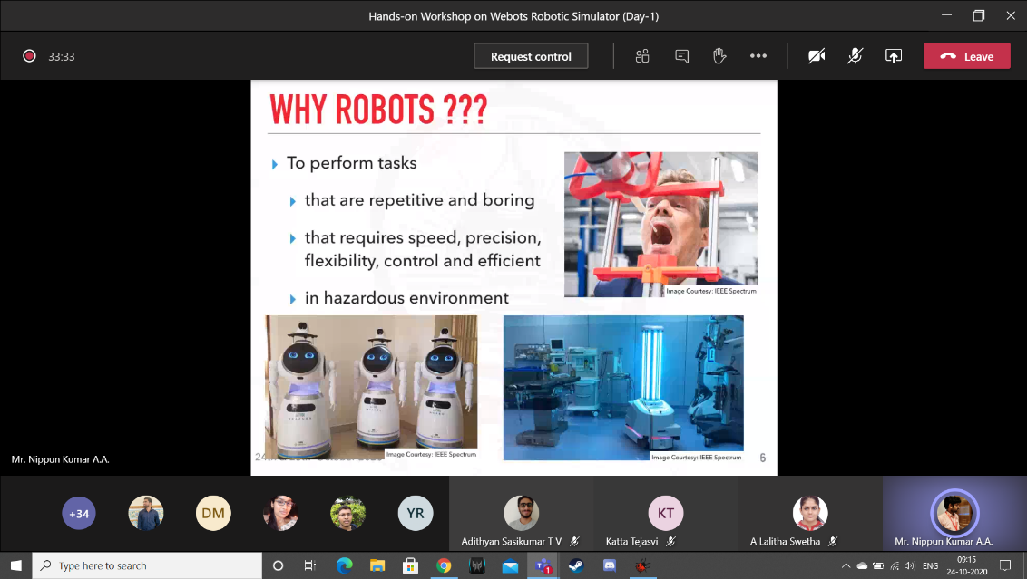
DAY - 2
The second day started off at 9:00 AM and concluded at 1.30 PM with a total of 4 sessions. It began with a session on programming of a mobile robot. Later, introduction to various sensors, sensor interfacing and applications a sensor were taught to the participants. An obstacle avoidance robot was developed and programmed in such a way that the bot turns away from the obstacle whenever it faces one in front of it. Finally, the participants were given an insight into the scope of implementation by showing some high-level end applications and capabilities that can be performed using this software. The event concluded with a Q and A session at 1:30PM.
Thus, the participants learnt to develop, code and simulate a robot along with all the troubleshooting aspects of simulation and the challenges associated with implementation.
